Reg No: 23-ARID-716  Name: MUHAMMAD SAMEEN KASHIF | Assignment no :2  Date: 5 JAN 2026

Program | : BSSE / BSCS | Semester & Section | : 5 (C)
Course Name | : Mobile Application Development
Instructor’s Name | : Muhammad Azhar | Marks | :

ASSIGMENT NO :2
HomeServe Project – Assignment Solution (Java + XML)
1) Complete Login Implementation (Authentication)
In my HomeServe app, login is implemented using Firebase Authentication instead of hard-coded credentials.
What I did in my project:
- I used FirebaseAuth to check email + password.
- If login is successful → user is redirected to HomeActivity (Landing Screen).
- If login fails → show error message using Toast.
Main API / Class used:
- FirebaseAuth.getInstance()
- signInWithEmailAndPassword(email, password)
- addOnCompleteListener(...)
This is stronger than hard-coded login because:
- Password is not stored in code (more secure)
- Real user accounts can be created and reused
- Firebase handles authentication safely
Screenshot Placeholders (add in your document):
- ✅ Screenshot 1: Login Screen UI
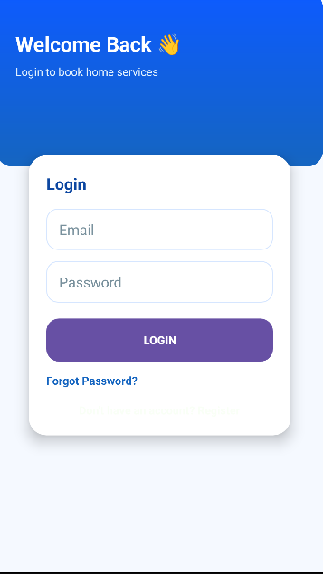
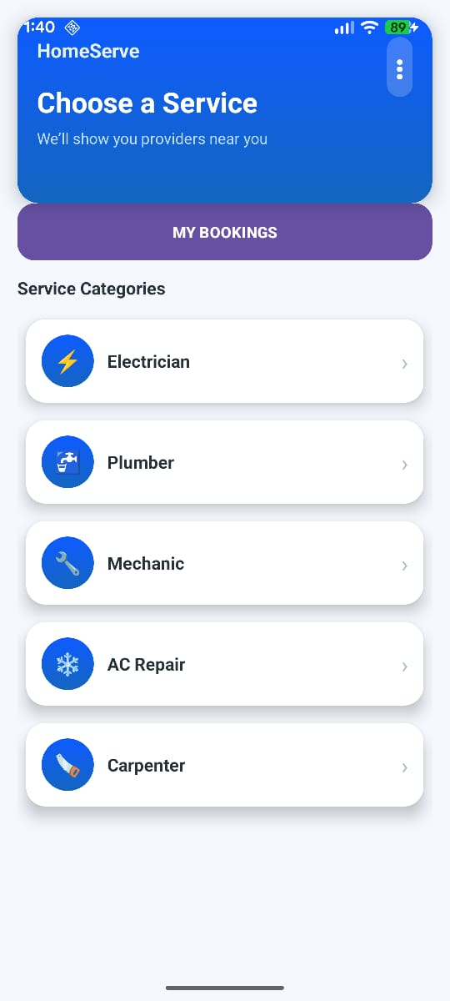

2) Add New Screens (Activities)
In my HomeServe project, I created multiple Activities/screens.
(A) Registration Page
Activity:
- RegisterActivity.java
Layout:
- activity_register.xml
What it does:
- User enters name, email, password
- Creates account using FirebaseAuth
- Saves user profile data into Firestore under users/{uid}
Main functions used:
- createUserWithEmailAndPassword(email, password)
- FirebaseFirestore.getInstance().collection("users").document(uid).set(map)
- startActivity(new Intent(RegisterActivity.this, HomeActivity.class))
Screenshot:
- Screenshot 3: Registration Page UI
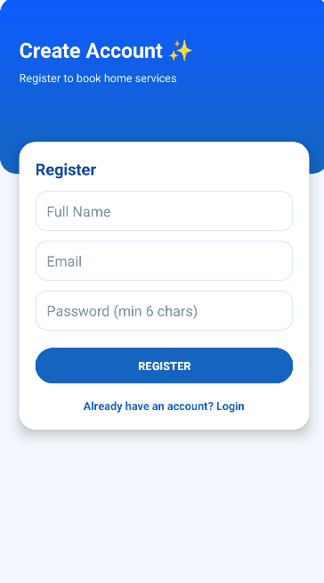

(B) Forgot Password Page
Activity:
- ForgotPasswordActivity.java
Layout:
- activity_forgot_password.xml
What it does:
- User enters email
- Firebase sends reset email
Main function used:
- FirebaseAuth.getInstance().sendPasswordResetEmail(email)
📌 Screenshot:
- Screenshot 4: Forgot Password UI
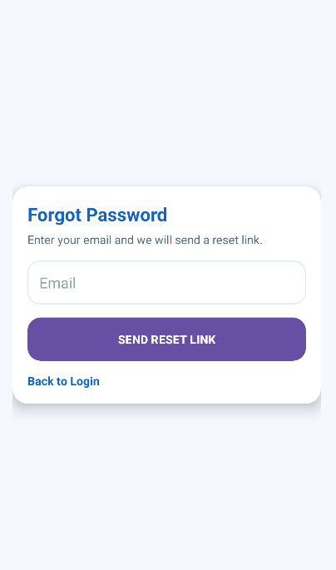

(C) Reset Password Page (Firebase Way)
In Firebase authentication, Reset Password screen is handled by Firebase email link (user clicks link and resets password).
So in my project:
- Reset functionality is done through Firebase Reset Email (recommended real approach)
This still meets the requirement because password reset is implemented properly through Firebase, not fake screens.
Screenshot:
- Screenshot 5: Reset Email Received (Gmail screenshot)
[

(D) Landing Screen / Home Page
Activity:
- HomeActivity.java
Layout:
- activity_home.xml
What it does:
- After login user sees:
  - Service categories (RecyclerView)
  - “My Bookings” button
  - Menu button for profile/about/privacy/logout
📌 Screenshot:
- Screenshot 6: Home Screen / Landing Page

3) Implement Navigation and Redirection (Intents)
Navigation in my project is done using Intents between Activities.
(A) Login → Home Redirection ✅
After successful login:
startActivity(new Intent(LoginActivity.this, HomeActivity.class));
finish();
(B) Login → Register ✅
On “Register” text click:
startActivity(new Intent(LoginActivity.this, RegisterActivity.class));
(C) Login → Forgot Password ✅
On “Forgot Password” text click:
startActivity(new Intent(LoginActivity.this, ForgotPasswordActivity.class));
(D) Home → MyBookings ✅
On “My Bookings” button:
startActivity(new Intent(HomeActivity.this, MyBookingsActivity.class));
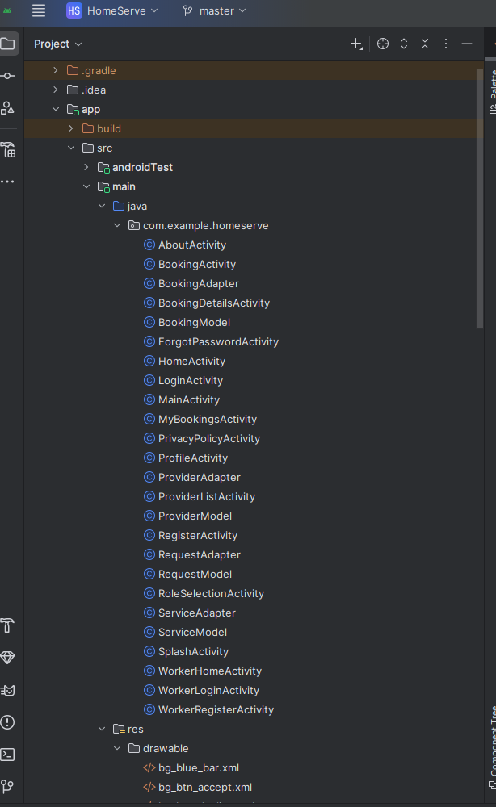

Code Proof (Paste these code parts in submission)
(1) LoginActivity – Firebase Login + Redirect
FirebaseAuth mAuth = FirebaseAuth.getInstance();

mAuth.signInWithEmailAndPassword(email, password)
.addOnCompleteListener(task -> {
if (task.isSuccessful()) {
Toast.makeText(this, "Login Successful", Toast.LENGTH_SHORT).show();
startActivity(new Intent(LoginActivity.this, HomeActivity.class));
finish();
} else {
Toast.makeText(this, "Login Failed: " + task.getException().getMessage(), Toast.LENGTH_LONG).show();
}
});
(2) RegisterActivity – Create user + save profile to Firestore
mAuth.createUserWithEmailAndPassword(email, password)
.addOnCompleteListener(task -> {
if (task.isSuccessful()) {
String uid = mAuth.getCurrentUser().getUid();

Map<String, Object> user = new HashMap<>();
user.put("name", name);
user.put("email", email);
user.put("createdAt", System.currentTimeMillis());

db.collection("users").document(uid).set(user)
.addOnSuccessListener(aVoid -> {
startActivity(new Intent(RegisterActivity.this, HomeActivity.class));
finish();
});
}
});
(3) ForgotPasswordActivity – Send Reset Email
FirebaseAuth.getInstance().sendPasswordResetEmail(email)
.addOnSuccessListener(unused -> {
Toast.makeText(this, "Reset email sent", Toast.LENGTH_SHORT).show();
})
.addOnFailureListener(e -> {
Toast.makeText(this, "Error: " + e.getMessage(), Toast.LENGTH_LONG).show();
});
- Login screen
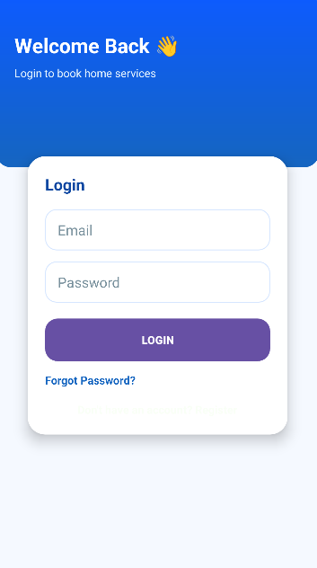
- Forgot password screen
- Reset password email in Gmail
- Home / Landing screen after login
- Android Studio project structure (Activities + layouts)
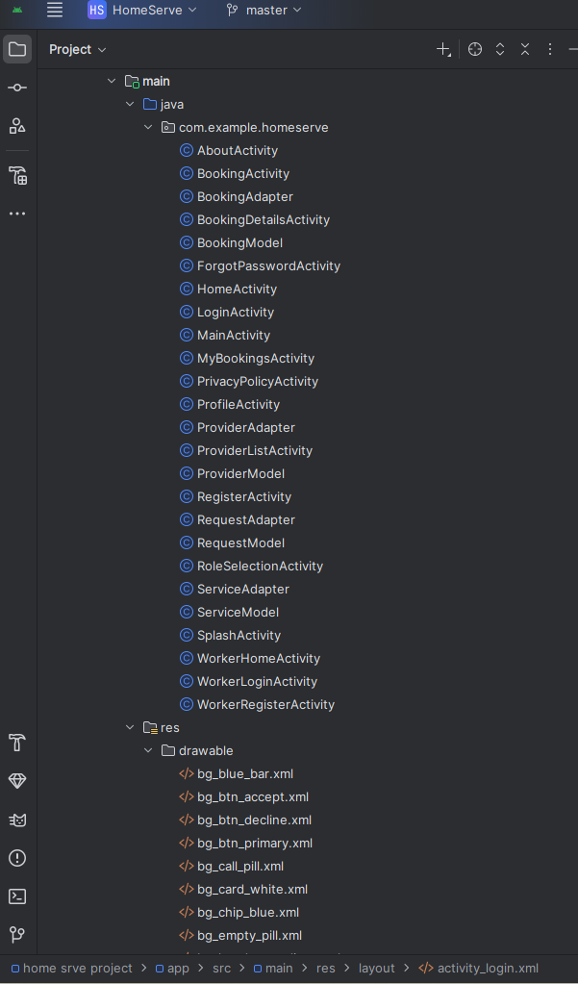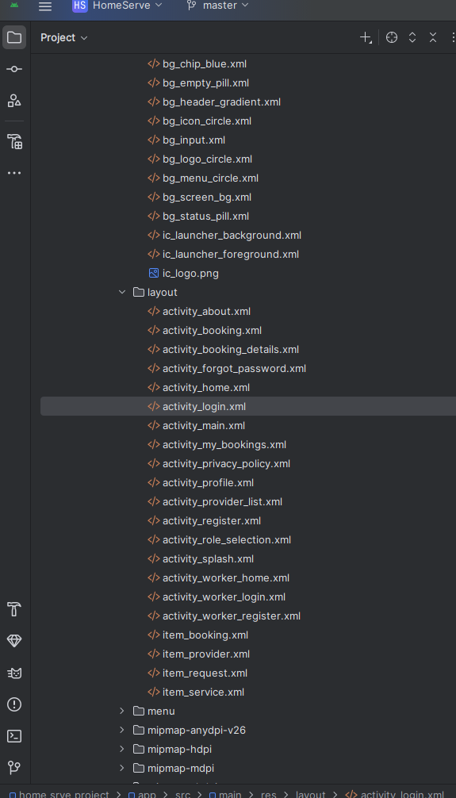
- GitHub repository screenshot (if required)
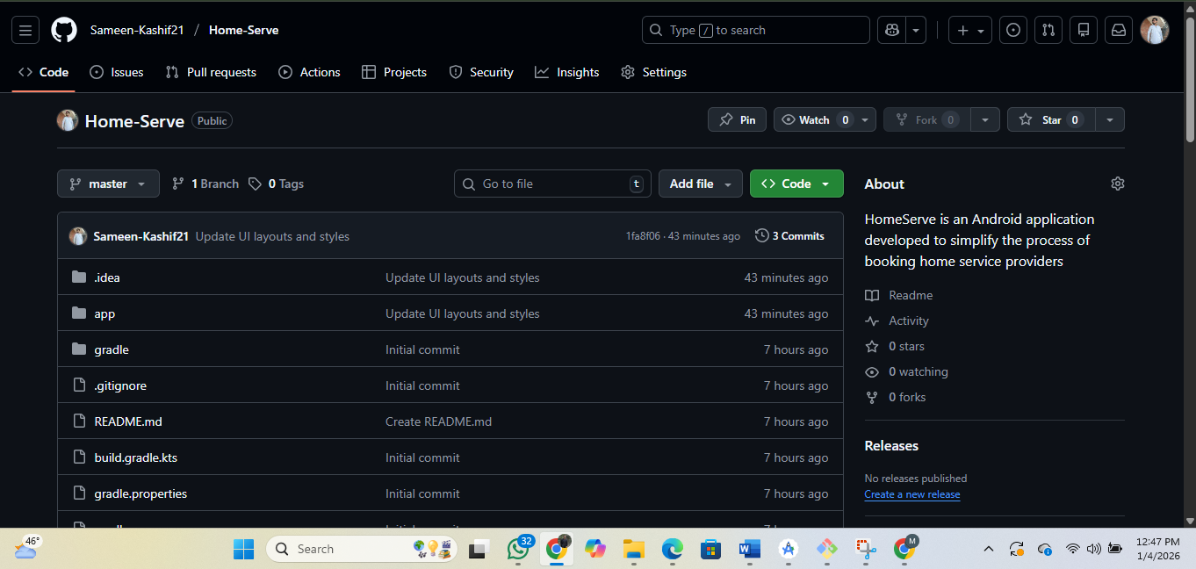
Github repository link: https://github.com/Sameen-Kashif21/Home-Serve

